**Linking Worksheets (3D Formulas)**

**Definition**:

Linking worksheets in Excel involves referencing data from multiple worksheets within the same workbook using 3D formulas. This process allows users to consolidate and analyze data from different sources or categories conveniently.

**Purpose**:

The primary purpose of linking worksheets is to streamline data analysis and reporting tasks by accessing information spread across various worksheets. It enables users to create dynamic reports, perform complex calculations, and gain insights from integrated datasets efficiently.

Follow these steps to effectively use 3D formulas in Excel:

Step 1: Open Excel Workbook

* Launch Microsoft Excel and open the workbook containing the worksheets you want to link.

Step 2: Navigate to Destination Worksheet

* Click on the worksheet where you want to create the 3D formula to reference data from other worksheets.

Step 3: Select Cell for Formula Entry

* Choose the cell where you want to insert the formula that will reference data from other worksheets.

Step 4: Begin Formula Entry

* Start typing the desired formula (e.g., SUM, AVERAGE, COUNT) followed by an open parenthesis "(" to begin the formula syntax.

Step 5: Specify Worksheet Names

* Type the name of the first worksheet from which you want to reference data, followed by an exclamation mark "!". For example: Sheet1!

Step 6: Select Data Range

* Use the mouse to click and drag to select the range of cells from the specified worksheet that you want to include in the calculation.

Step 7: Continue Adding Worksheets

* If you want to include data from additional worksheets in the calculation, type a comma "," and repeat steps 5 and 6 to specify the names and ranges of other worksheets.

Step 8: Complete Formula

* Once you have specified all the worksheets and ranges, close the parentheses ")" to complete the formula entry.

Step 9: Press Enter

* Press the Enter key on your keyboard to execute the formula. The result of the 3D calculation will be displayed in the selected cell.

Step 10: Verify Results

* Check the calculated result to ensure it accurately reflects the data from the linked worksheets. If necessary, review and adjust the formula to correct any errors.

Step 11: Repeat for Other Formulas

* Repeat the above steps as needed to create additional 3D formulas for other calculations or analyses across different worksheets.

Step 12: Save Workbook

* After completing your analysis, make sure to save your Excel workbook to retain the 3D formulas and linked data for future reference.

Step 13: Test and Validate

* Before finalizing your analysis or report, thoroughly test and validate the 3D formulas to ensure they accurately reflect the intended data relationships and calculations.

Reference: <https://www.excel-easy.com/examples/3d-reference.html>

**Consolidating Data from Multiple Worksheets**

The quickest way to consolidate data in Excel (located in one workbook or multiple workbooks) is by using the built-in Excel Consolidate feature.

Let's consider the following example. Supposing you have a number of reports from your company regional offices and you want to consolidate those figures into a master worksheet so that you have one summary report with sales totals of all the products.

As you see in the screenshot below, the three worksheets to be consolidated have a similar data structure, but different numbers of rows and columns:

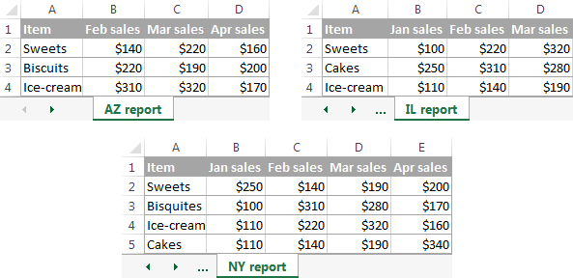

**To consolidate the data in a single worksheet, perform the following steps:**

* **1.**  For the Excel Consolidate feature to work correctly, make sure that:
* Each range (data set) you want to consolidate resides on a separate worksheet. Don't put any data on the sheet where you plan to output the consolidated data.
* Each sheet has the same layout, and each column has a header and contains similar data.
* There are no blank rows or columns within any list.

**2. Run Excel Consolidate.** In the master worksheet, click the upper-left cell where you want the consolidated data to appear, go to the *Data* tab and click *Consolidate*.

* 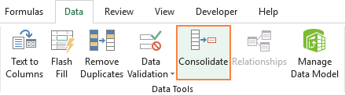
* **3. Configure the consolidation settings.**
* The *Consolidate* dialog windows appears and you do the following:
  + **\*** In the *Function* box, select one of the summary functions you want to use to consolidate your data (Count, Average, Max, Min, etc.). In this example, we select *Sum*.
  + **\*** In the *Reference* box, clicking the *Collapse Dialog* icon Collapse Dialog icon. and select the range on the first worksheet. Then click the *Add* button to have that range added to the *All references* Repeat this step for all the ranges you want to consolidate.
* If one or some of the sheets reside in another workbook, click the *Browse* bottom to locate the workbook.
* 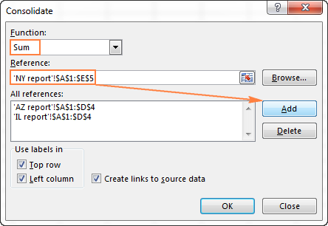
* **4. Configure the update settings**. In the same *Consolidate* dialog window, select any of the following options:
  + I. Check the Top row and/or Left column boxes under *Use labels*, if you want the row and/or column labels of the source, range to be copied to the consolidation.
  + Ii. Select the Create links to the source data box if you want the consolidated data to update automatically whenever the source data changes. In this case, Excel will create links to your source worksheets as well as an outline like in the following screenshot.
* 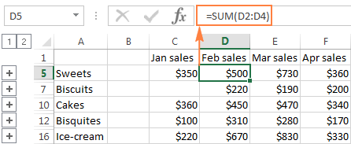
* If you expand some group (by clicking the plus outline symbol), and then click on the cell with a certain value, a link to the source data will display in the formula bar.
* 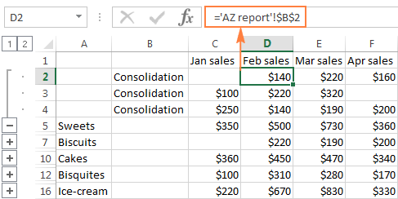

As you see, the Excel Consolidate feature is very helpful for pulling together data from several worksheets. However, it does have a few limitations. In particular, it works for numeric values only and it always summarizes those numbers in one way or another (sum, count, average, etc.)